**Project Report**

**Name : PRASHANT VERMA**

**Name : KALPANSH VERMA**

**Name : DHARMENDRA SINGH**

**Name : SHUBHAM GUPTA**

**Email: prashant.verma54@gmail.com**

**Title : AI RECRUITER**

**Category: Artificial Intelligence**

**TEAM: STAR WARS**

**IBM HACK CHALLENGE 2O2O**

* **Introduction**

**1.1 Project Overview:**

AI (artificial intelligence) seems to be taking the world of HR and recruitment by a storm. Previous years have seen countless different articles and blog posts covering AI. On top of that, more and more recruitment softwares seems to make use of AI in some form or another. It’s safe to say, AI in recruitment and HR can be seen as the most present trend to dominate the space in the next years.

As more and more HR tech trends lists appear, two things become clear:

1 The recruitment market is buzzing with innovation

2 The advancement and applications of AI in recruitment have only just kicked off.

This Project is about building a smart document analyzer, which screens the candidate profile and categorizes the candidate skill & job roles. Also build AI powered bot to schedule the interview with person to have preliminary round of interview through chat

**Project Requirements**: Python, IBM Cloud, IBM Watson

**Functional Requirements**: IBM cloud

**Technical Requirements**: AI , WATSON AI, PYTHON

**Software Requirements**: Watson assistant, Watson discovery, Node Red ,Knowledge Studio.

**1.2 Scope of Work**

* Create a customer care dialog skill in Watson Assistant
* Use Knowledge Studio for Document Analyzing
* Deploy the Knowledge Studio model to Watson Discovery to post queries to Watson Discovery.
* Create an IBM Cloud Functions web action that allows Watson Assistant to post queries to Watson Discovery.
* Build a web application with integration to all these services & deploy the same on IBM Cloud Platform using NODE RED service.

**2. Literature Survey**

* **Proposed Problem**

AI (artificial intelligence) seems to be taking the world of HR and recruitment by a storm. Previous years have seen countless different articles and blog posts covering AI. On top of that, more and more recruitment softwares seems to make use of AI in some form or another. It’s safe to say, AI in recruitment and HR can be seen as the most present trend to dominate the space in the next years.

* **Proposed Solution**

**Steps**

* Create IBM Cloud services
* Configure Watson Assistant
* Configure Knowledge Studio.
* Deploy model in Watson Discovery Service
* Create IBM Cloud Functions action.
* Create a Node red flow to connect all the services together.
* Create flow and configure node
* Deploy and run Node Red app.
* **Create IBM Cloud services**

Create the following services:

* Watson Assistant
* Node Red
* Knowledge Studio
* Watson Discovery
* Cloud Function

**1.Configure Watson Assistant**

Launch the Watson Assistant tool and create a new dialog skill. Select the Use sample skill option as your starting point. This dialog skill contains all of the nodes needed to have a typical Interview Conversation with the Candidate.

*Add new intent*

Create Intends that represent the questions an Interviewer should ask in an Interview like Personal Details, Educational Qualifications ,skills , Achievements etc...

*Create new dialog node*

Now we need to add a node to handle our intent. Click on the Dialog tab, then click on the drop-down menu for the Candidate Responces, and select the Add node below option.

Add Different Responces for different intents added as questions asked by HR for the Interview Proess .

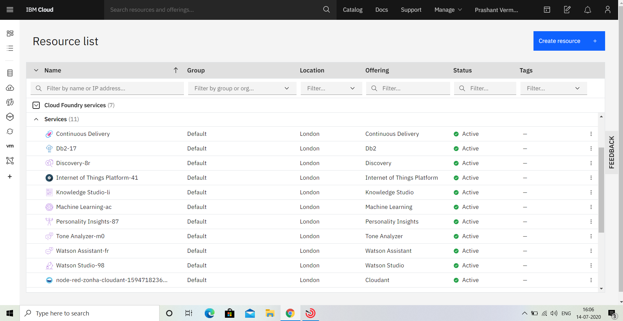

From the IBM CLOUD DashBoard go to Watson Assistant Service

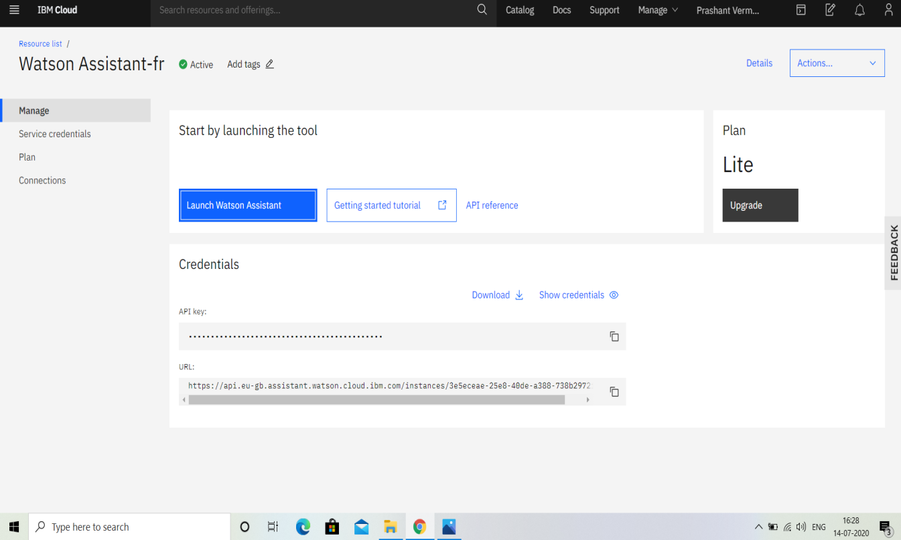

Launch the Watson Assistant Service

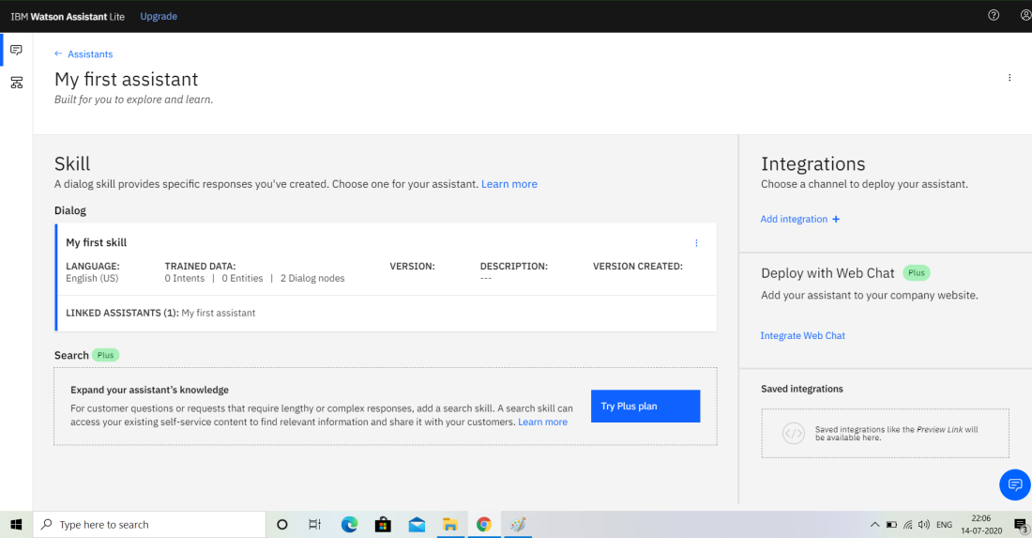

Create a New Assistant Service such as STAR WARS RECRUITER as i have created in

the above Image and add different Intents ,Entities and Dialog nodes to the

Watson Assistant Service.

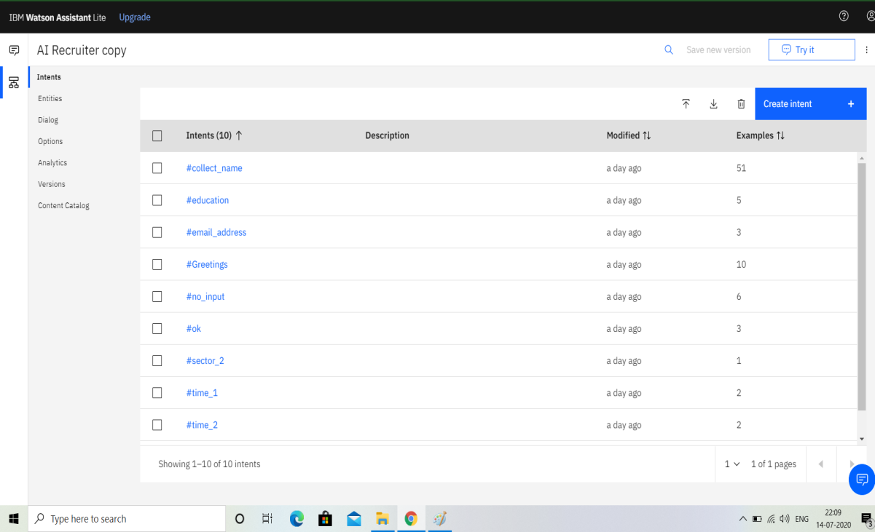

These are some of the Intents that i have added for the Question asked by the Hr

in the Interview Process like Achievements ,Skills etc...

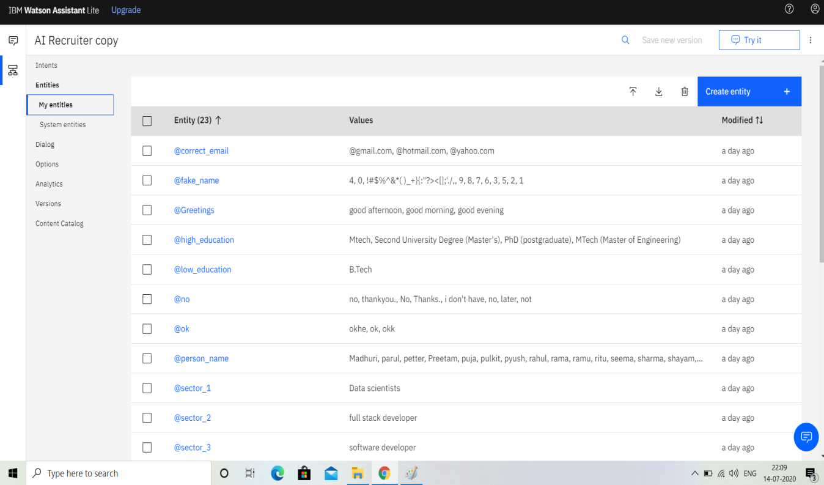

These are some of the Entities that i have added for conditions in Dialogue nodes

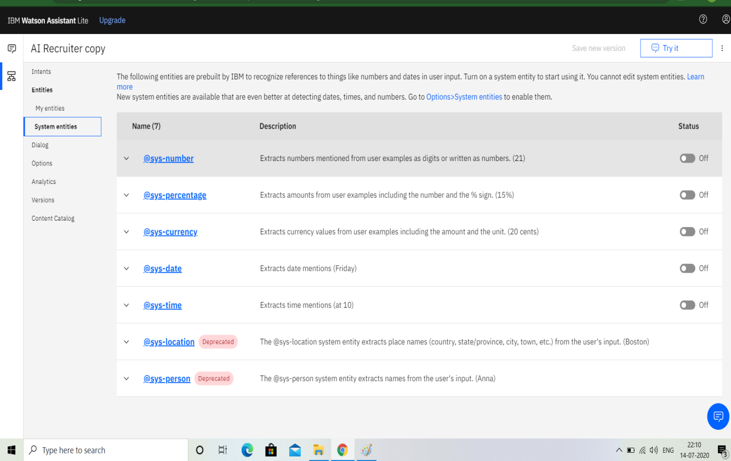

We can even add different inbuild System Entities such as time,

date ,number ,percentage etc..

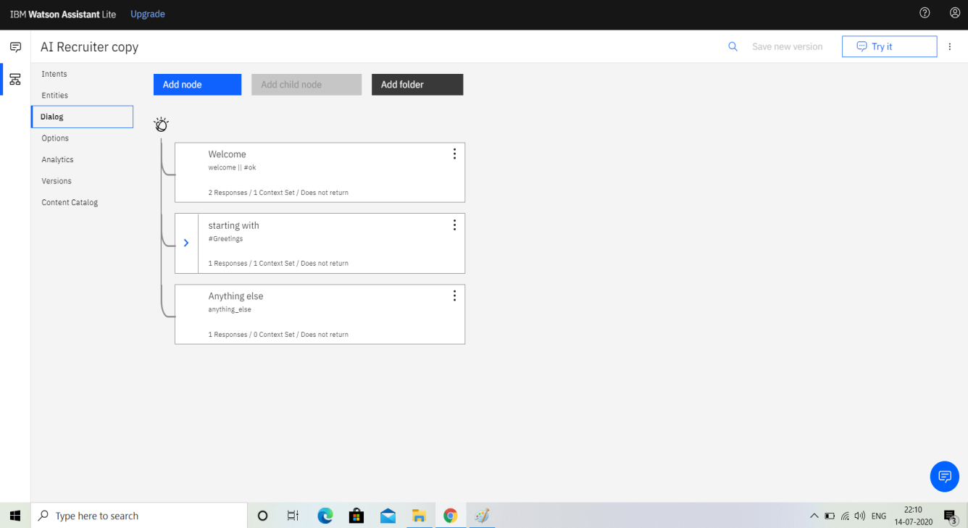

These are some of the responces that i have gave to the projects completed or

Done by the Candidates .

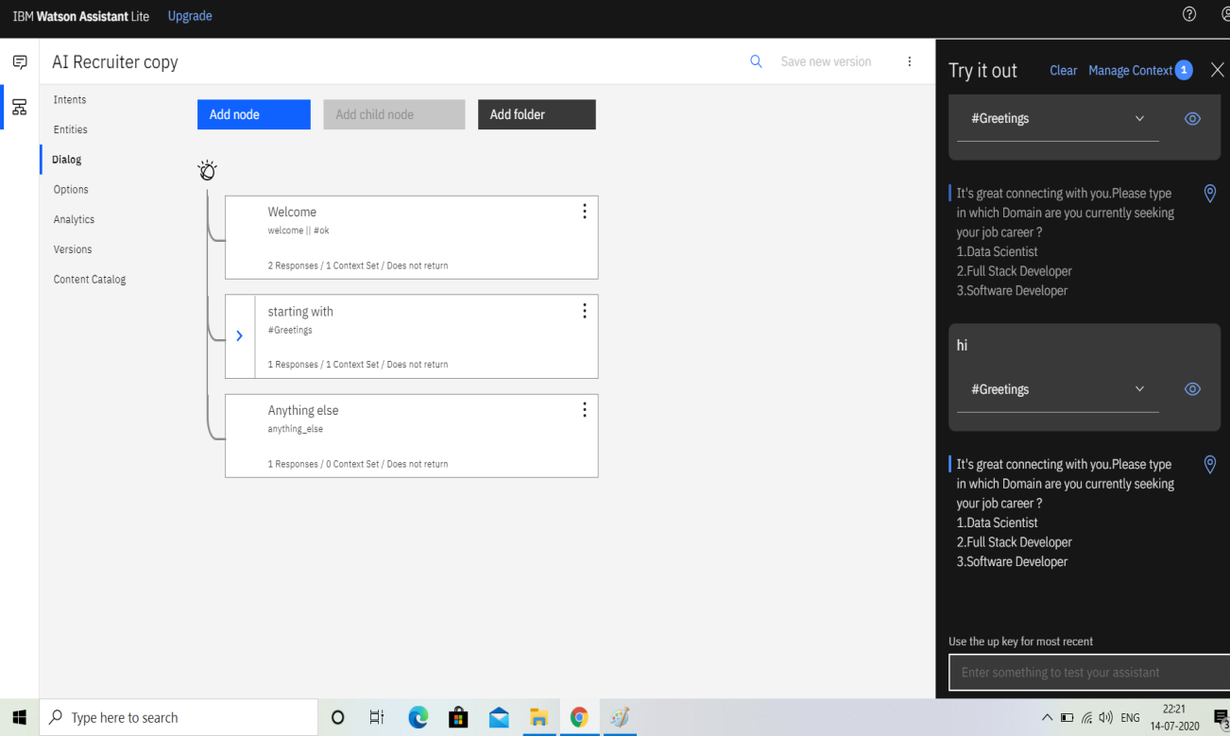

After Entering all the Dialog Nodes the watson Assistant gets Trained based on

the Responces given in the Dialog nodes based on the intents and Entities.

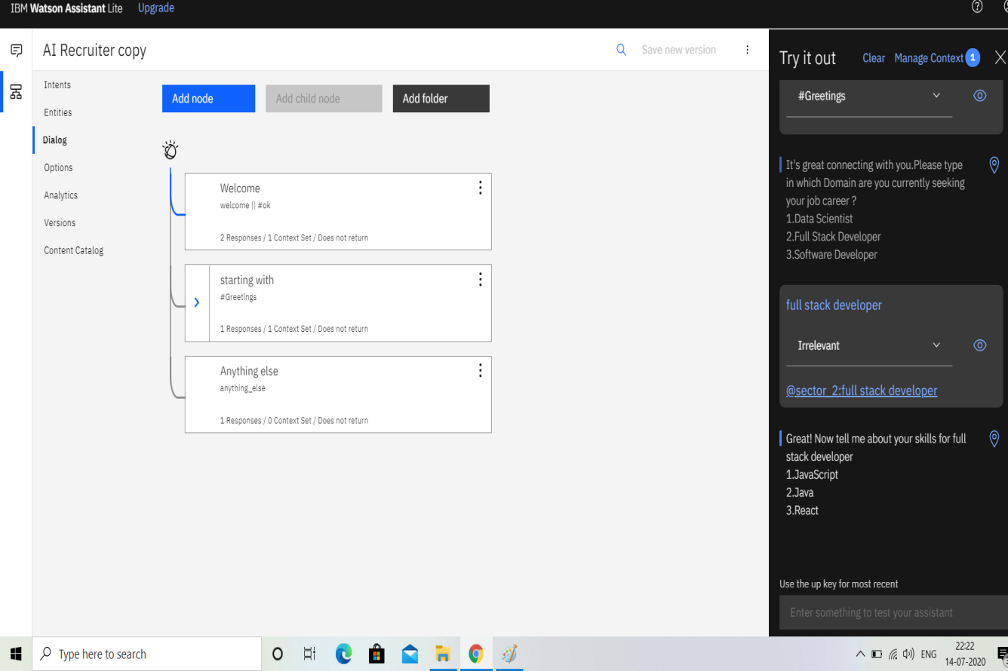

This is the Chatbot responces given by the Watson assistant for the questions

asked by the interviewer .

Now Integrate this Watson Assistant Service into Node red Service for the Web

Dashboard preview of the Chatbot Responces

**2.NODE RED** :

* **Create flow and configure node:**

At first go to manage palette and install dashboard. Now, Create the flow with the help of following node:

* Inject
* Assistant
* Debug
* Function
* Ui_Form
* Ui_Text

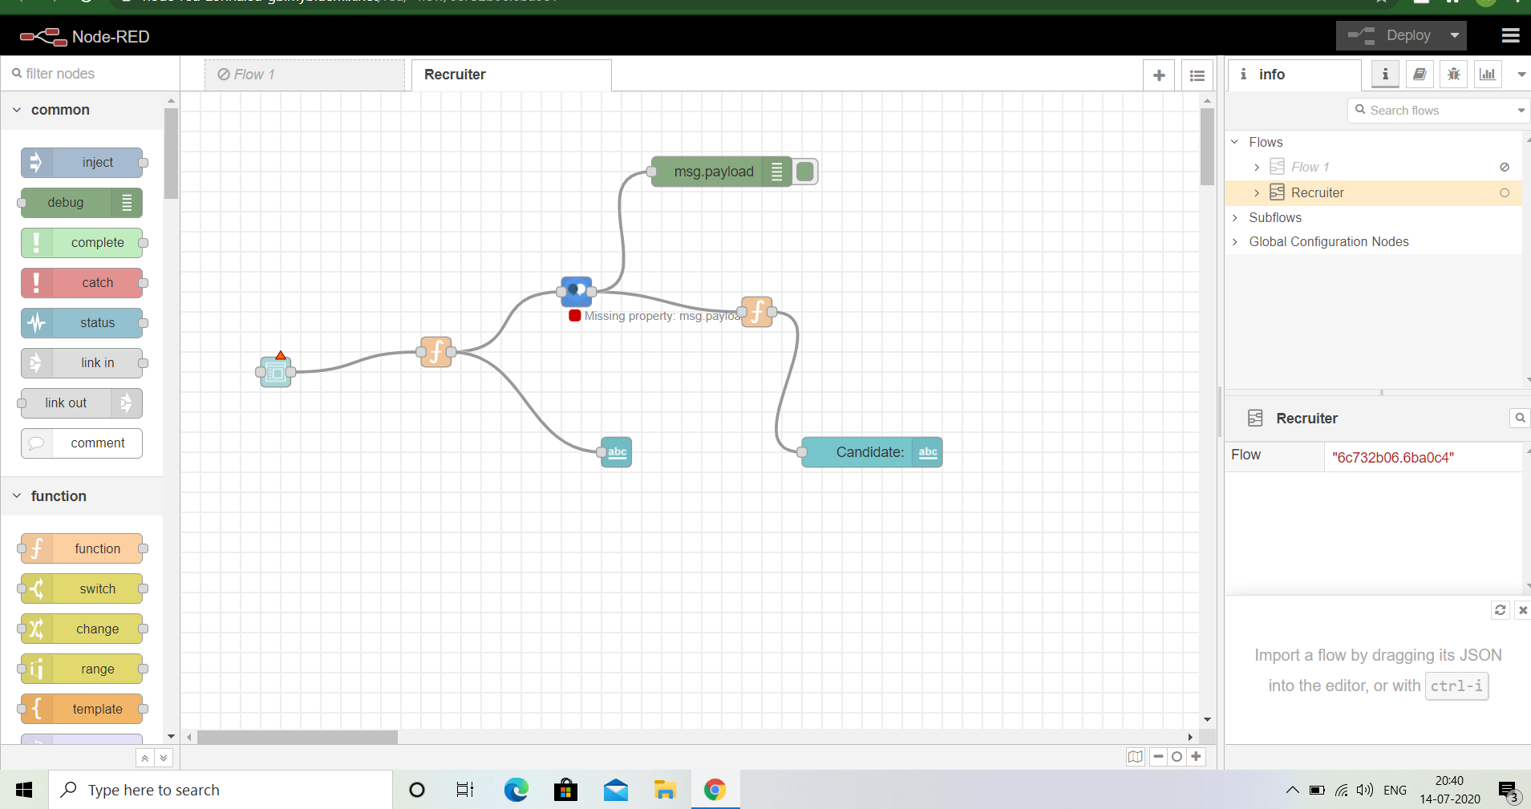

* **Deploy and run Node Red app.**

Deploy the Node Red flow.

Then copy the link url upto .net/ and paste at a new tab by ui at the end of the url, like this,

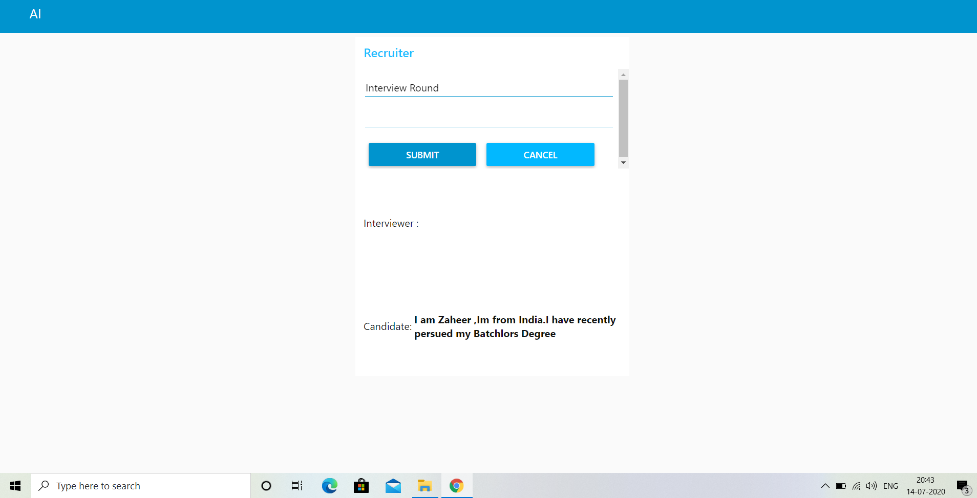

The chatbot responds with each question asked with relevent responce

**3.knowledge Studio:**

Coming to Knowledge Studio it is used for Document Analyzing .

here we are using Knowledge studio for resume analyzing we upload

different resumes and ass entity types and train the resume documents based

on the entitiy types .we also add dictionaries to match the entities examples

that are present in the resume document.

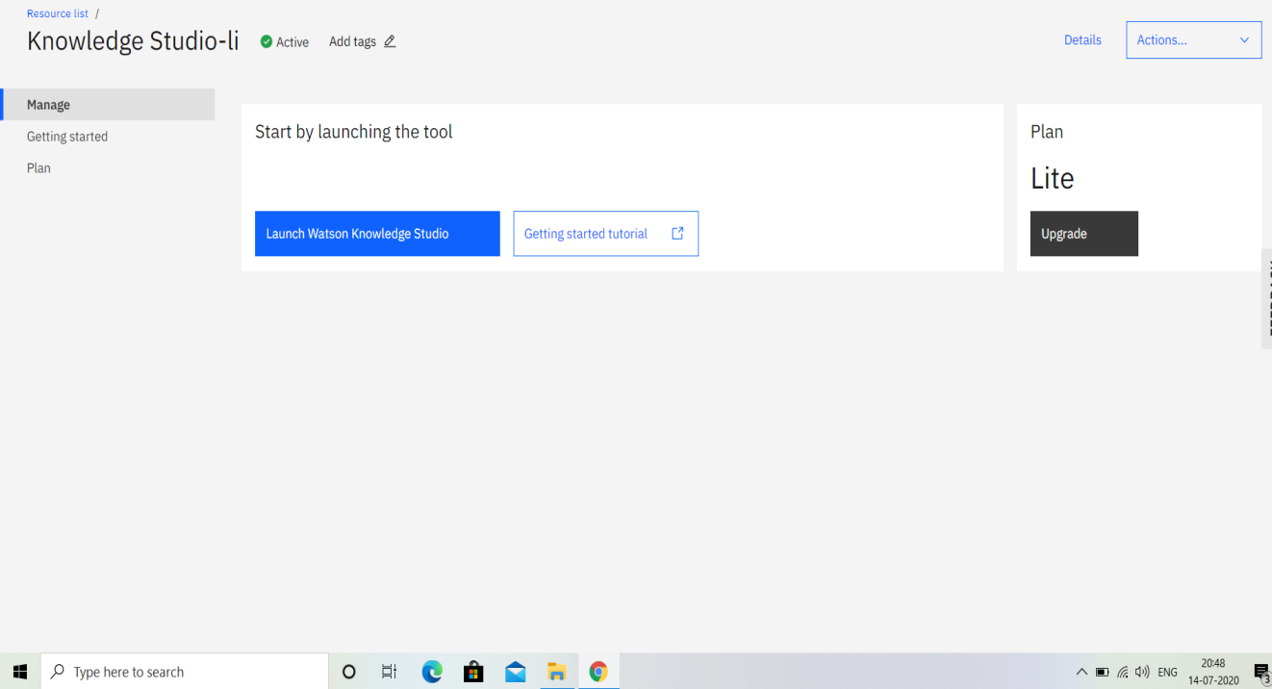

From Resource List Go to Knowledge studio and Launch the Knowledge

Studio

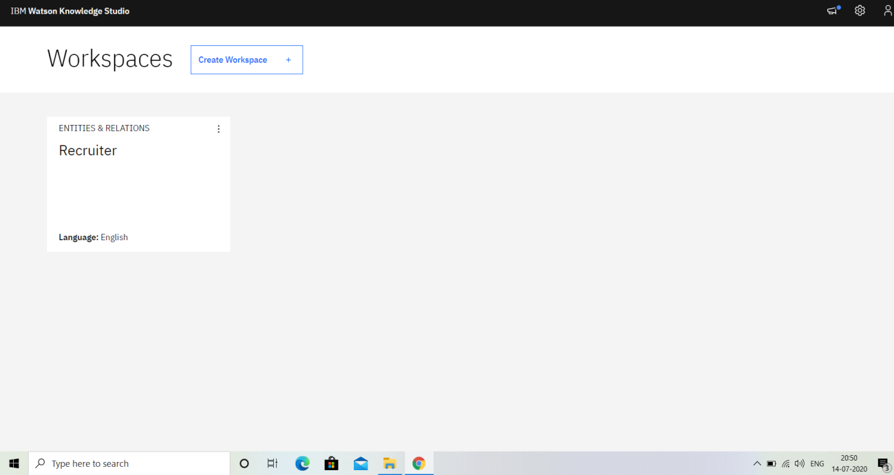

create a Workspace as i have created Analyzer as my Workspace for

Document Analyzing

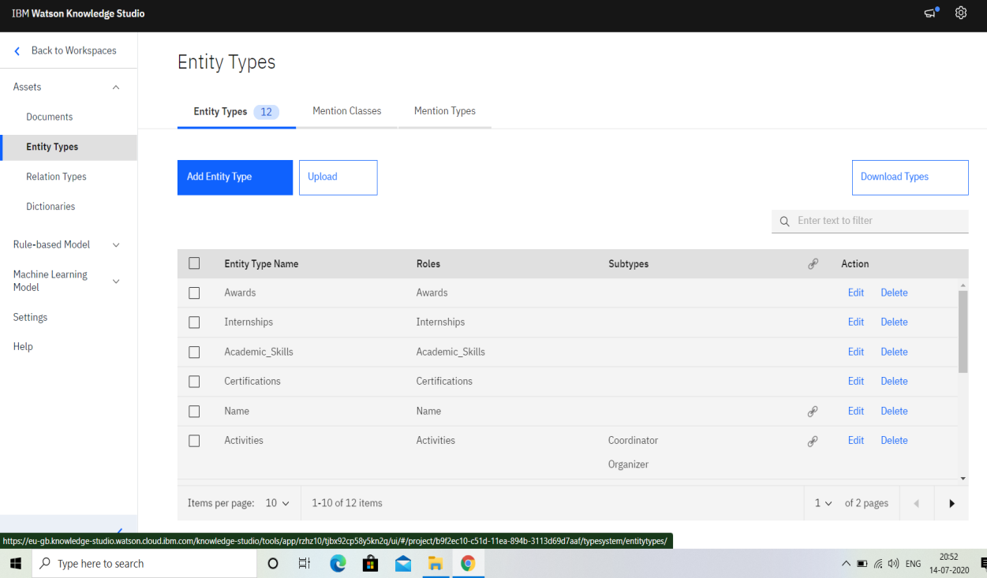

These are some of the Entity types that i have used for Skills ,

Awards ,Achievements etc..

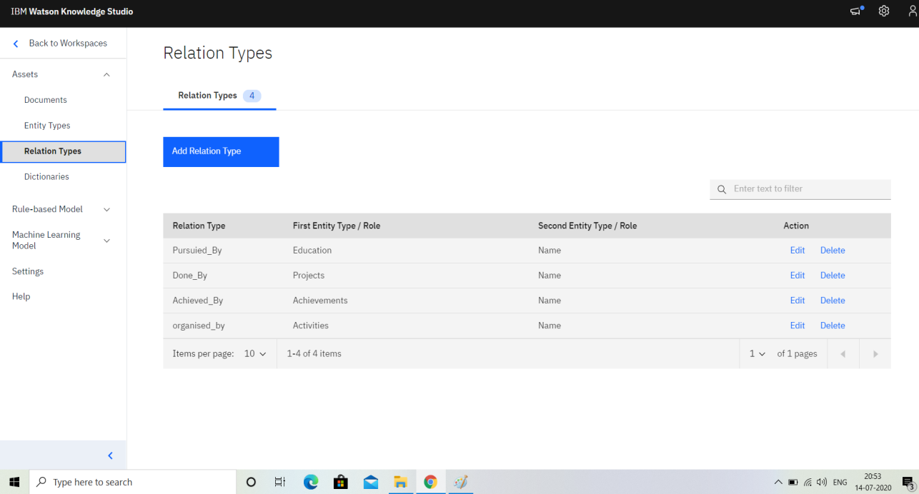

next add Relations to the entities and candidate to connect the candidate to

the entity types with relations such as Done_by for projects done by the

candidate,Pursuied_by for the courses or education pursuied by the

candidate etc..

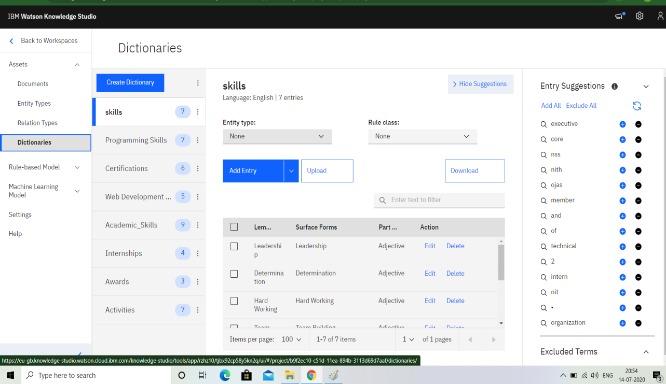

After this add Dictionaries to related the keywords used for the Entity types

such as Team building,good communications,problem solving which could

be the skills a candidate can have

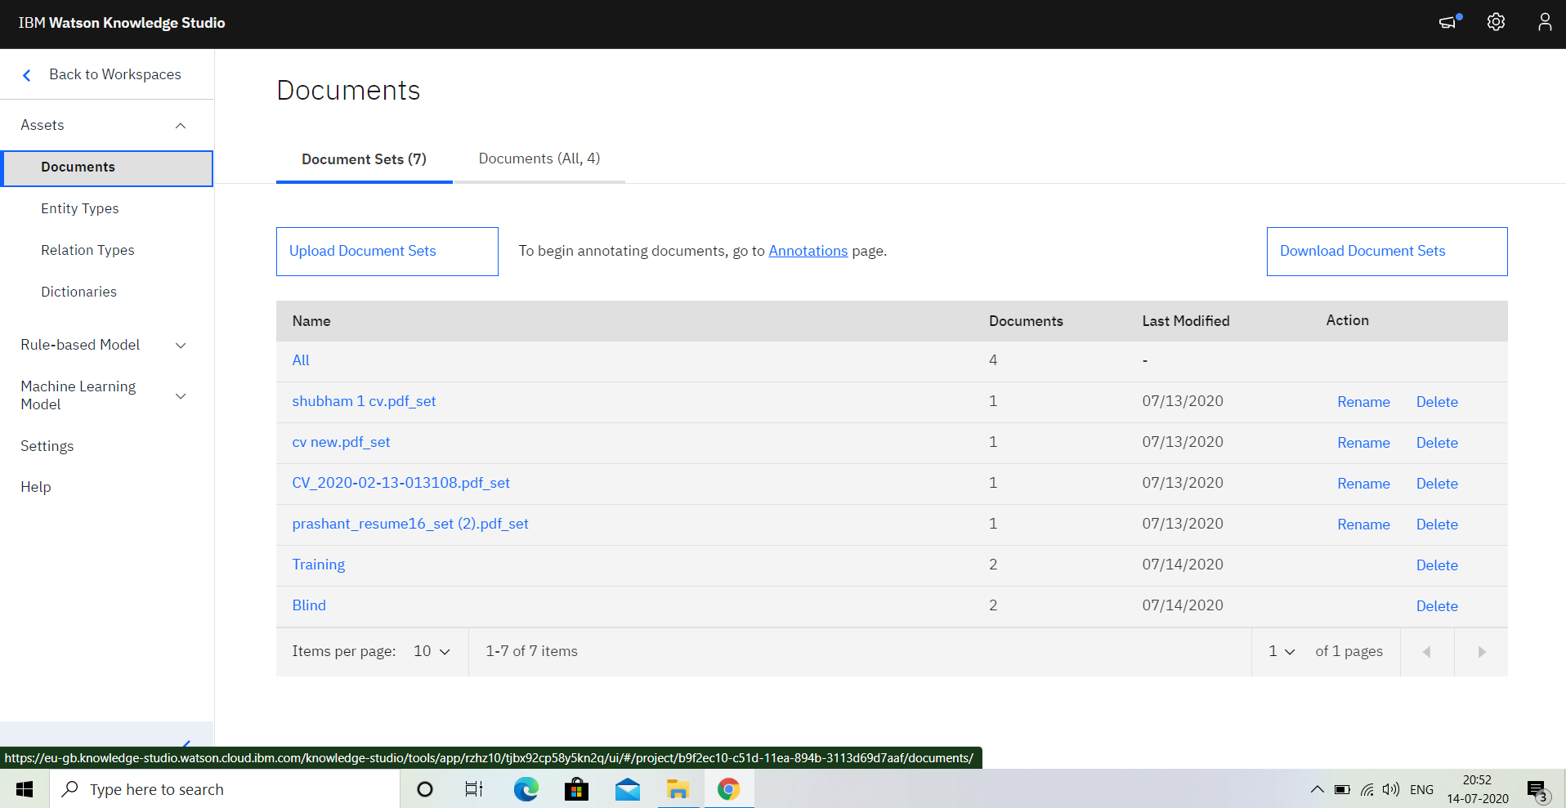

here we add some documents for analyzing by annotating the documents

with the Entities and sub entities and relations

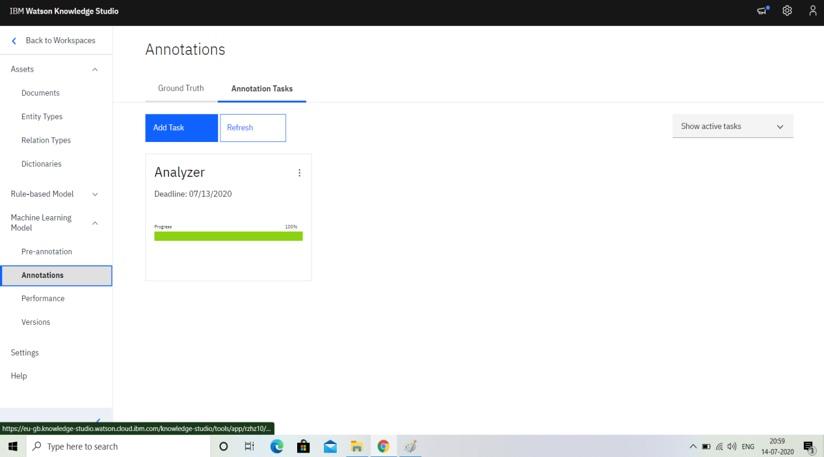

Here the Annotation is done by selecting the relevent entity types from the

documents by analyzing the documents

here Set1 and set2 are different people dividing the Documents for

Annotating them .

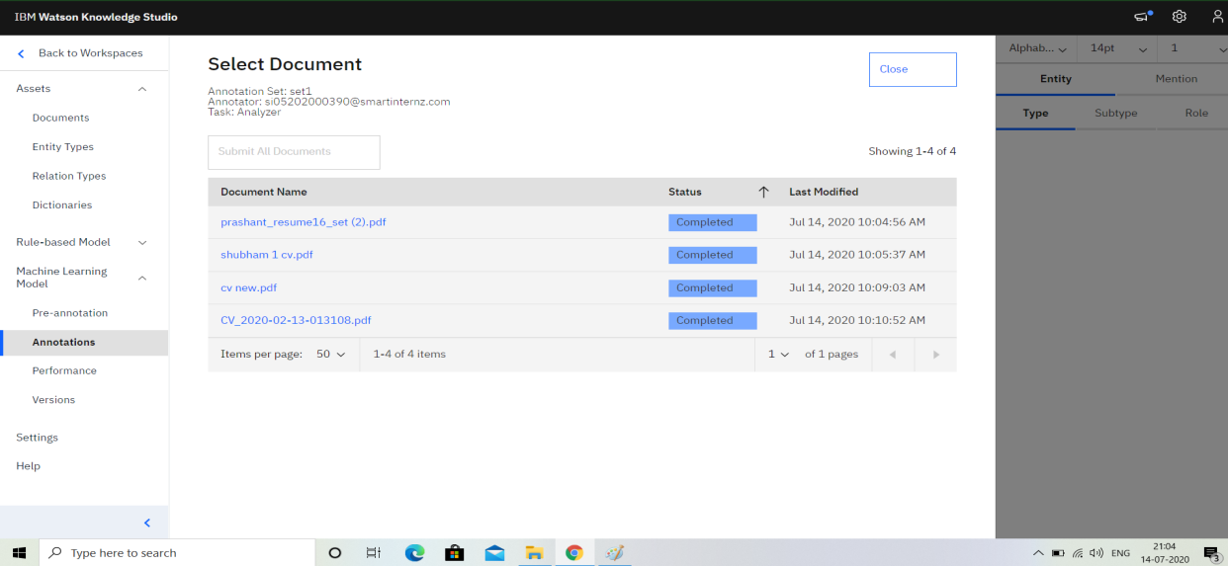

Set1 annotated the following Documents and the Remaining are annotated by

Set2.

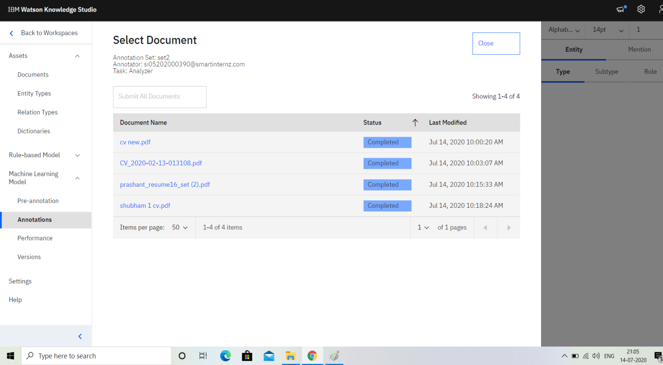

This is the Process of Annotating the Document based on the Entity types by

selecting the words related to the entity types and sub entity types which are

differentiated with different colours as shown.

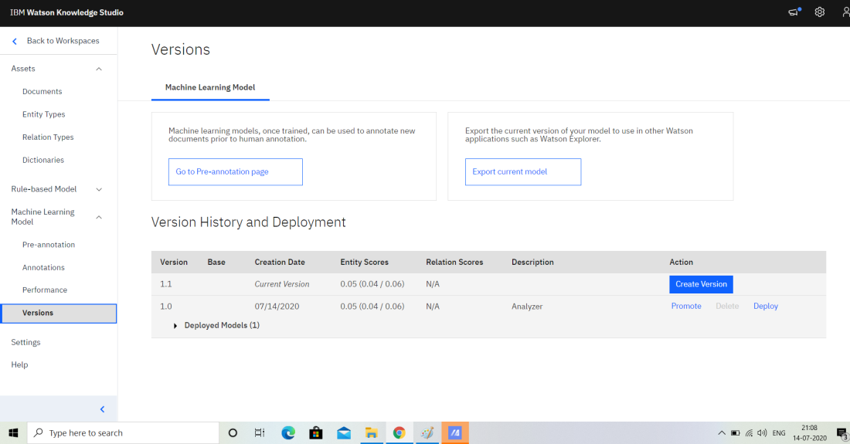

The next Process is Versions in which Version for the Model is created and

the model is Deployed using Watson Discovery or Natural Language

Processing or Machine Learning.

Here i Have taken Watson Discovery for Deployment

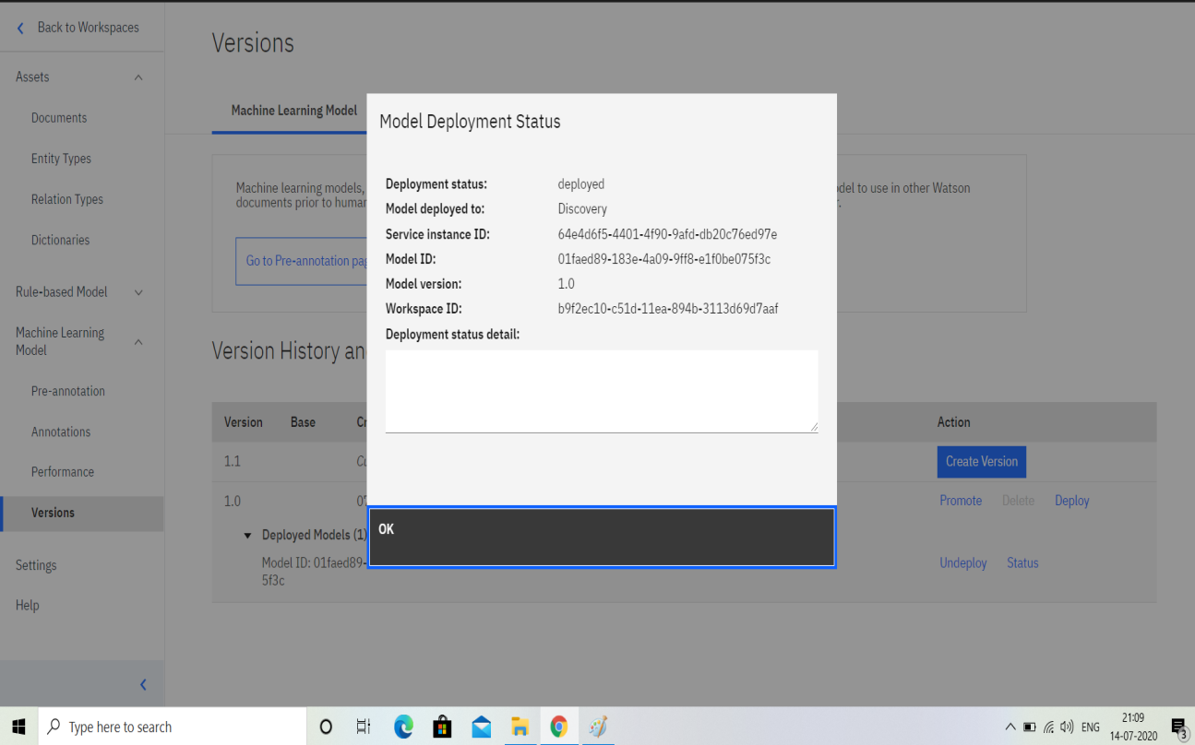

This is the Model Deployment Status of our Model

**4. Watson Discovery:**

The Next Deployment Process is done in Watson Discovery

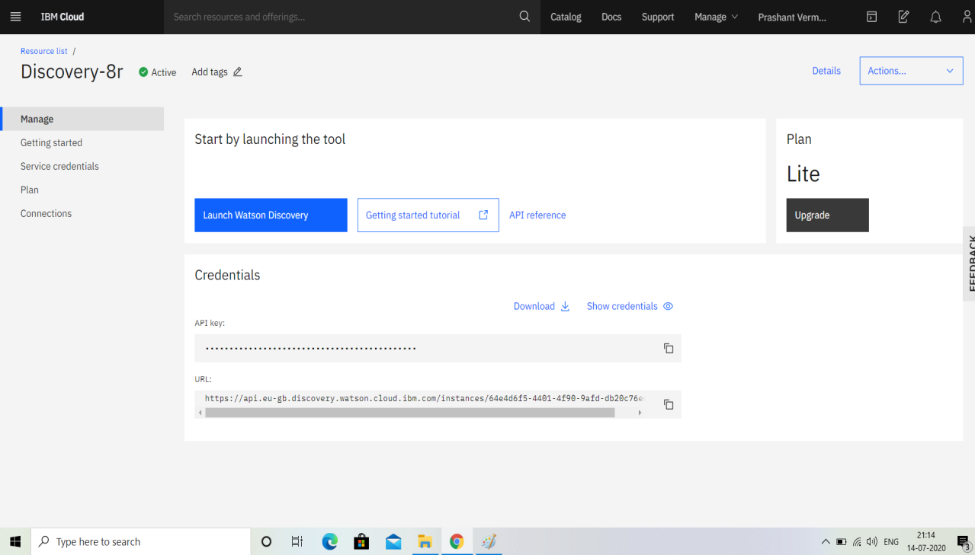

from the Resource List go to Discovery Service and Launch the Discovery Service

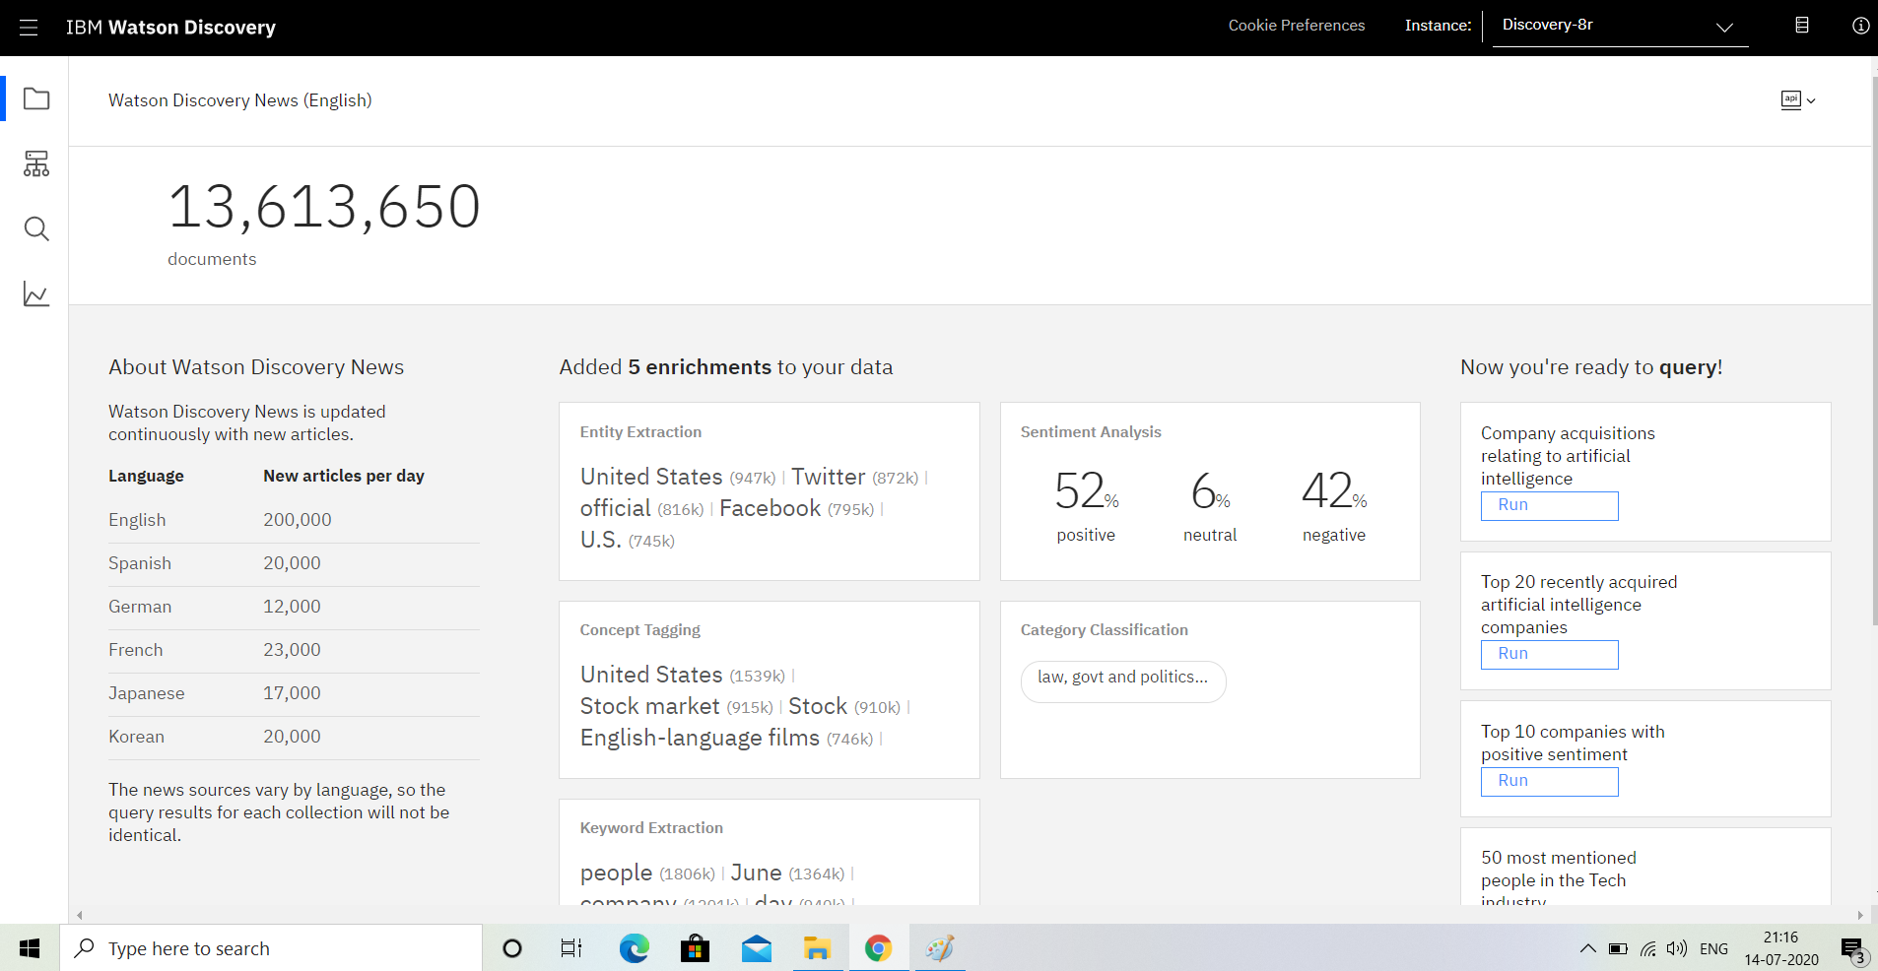

This is our Discovery service that is created when we deploy the model using

watson Discovery

Here we can see the Enrinchments of our Data and also the Sentiment

Analysis of our data

we can run the query using the Build Query Option and Run any Query

related to the document

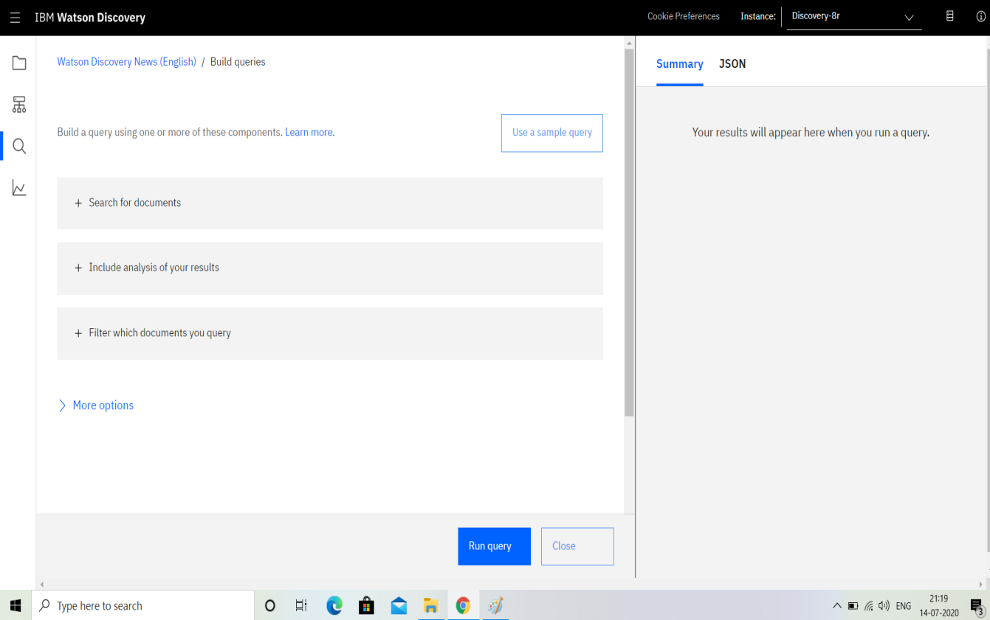

Here i have asked for the Projects and it Responded with the Details about

Project from the Document .

In this Way we can retrieve the data from the Document through Watson

Discovery

**5.Create IBM Cloud Functions action**

Now let's create the web action that will make queries against our Discovery collection.

Start the IBM Cloud Functions service by selecting Create Resource from the IBM Cloud dashboard. Enter functions as the filter, then select the Functions card:

From the Functions main panel, click on the Actions tab. Then click on Create. From the Create panel, select the Create Action option.

On the Create Action panel, provide a unique Action Name, keep the default package and select the Node.js 10 runtime.

Click the Create button to create the action.

Once your action is created, click on the Code tab:

In the code editor window, cut and paste in the code from the disco-action.js file found in the action’s directory of your local repository. The code is pretty straight-forward - it simply connects to the Discovery service, makes a query against the collection, then returns the response.

If you press the Invoke button, it will fail due to credentials not being defined yet. We'll do this next. Select the Parameters tab:

Add the following keys:

url

environment_id

collection_id

iam_apikey

For values, please use the values associated with the Discovery service you created in the previous step. Now that the credentials are set, return to the Code panel and press the Invoke button again. Now you should see actual results returned from the Discovery service:

Next, go to the Endpoints panel:

Click the checkbox for Enable as Web Action. This will generate a public endpoint URL.

Take note of the URL value, as this will be needed by Watson Assistant in a future step.

To verify you have entered the correct Discovery parameters, execute the provided curl command. If it fails, re-check your parameter values.

**3.Theoretical Analysis**

**3.1 Hardware and Software Designing**

**Project Requirements**: Python, IBM Cloud, IBM Watson

**Functional Requirements**: IBM cloud

**Technical Requirements**: AI, ML, WATSON AI, PYTHON

**Software Requirements**: Watson assistant, Watson discovery.

**4.Experimental Investigations**

**Watson Assistant:**

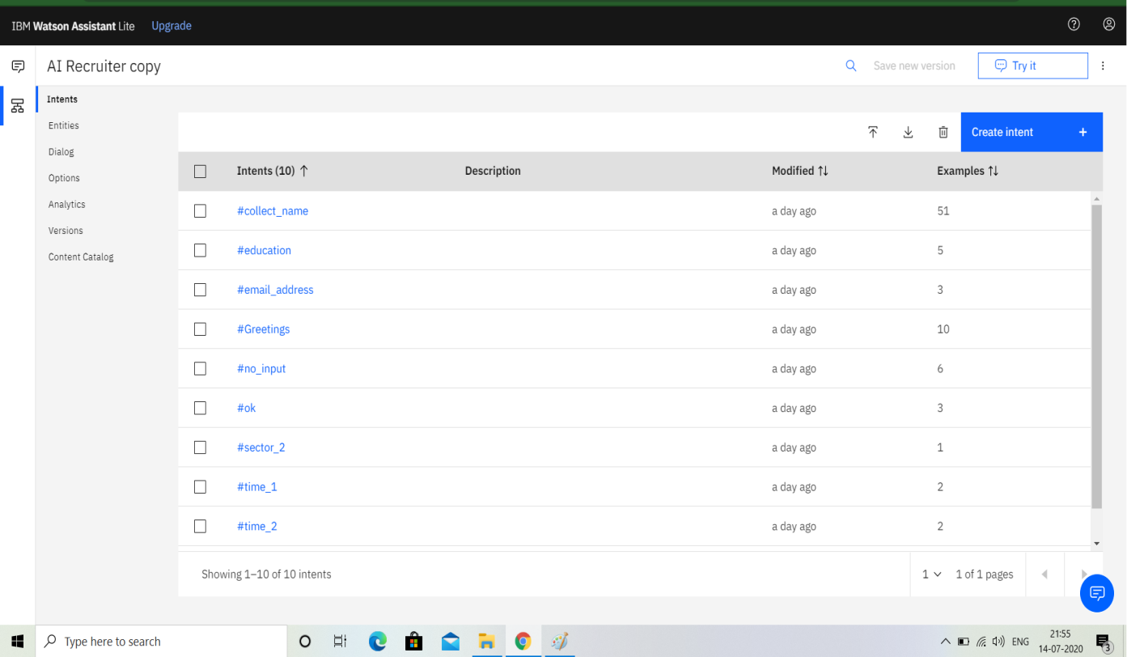

**Knowledge Studio:**

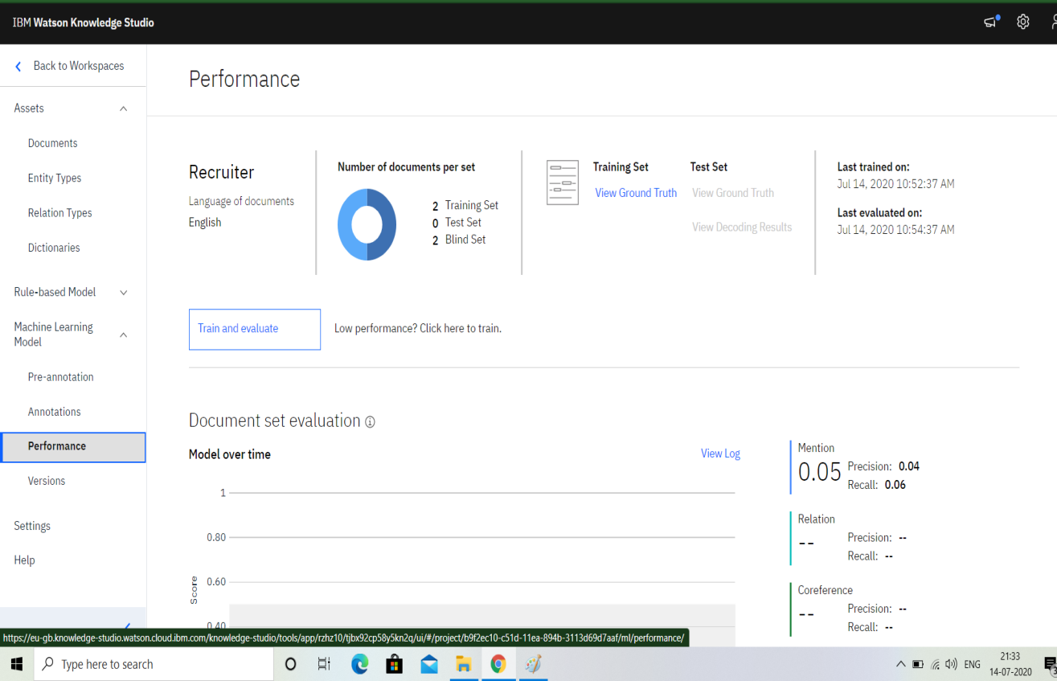

**Watson Discovery:**



**Cloud Function:**

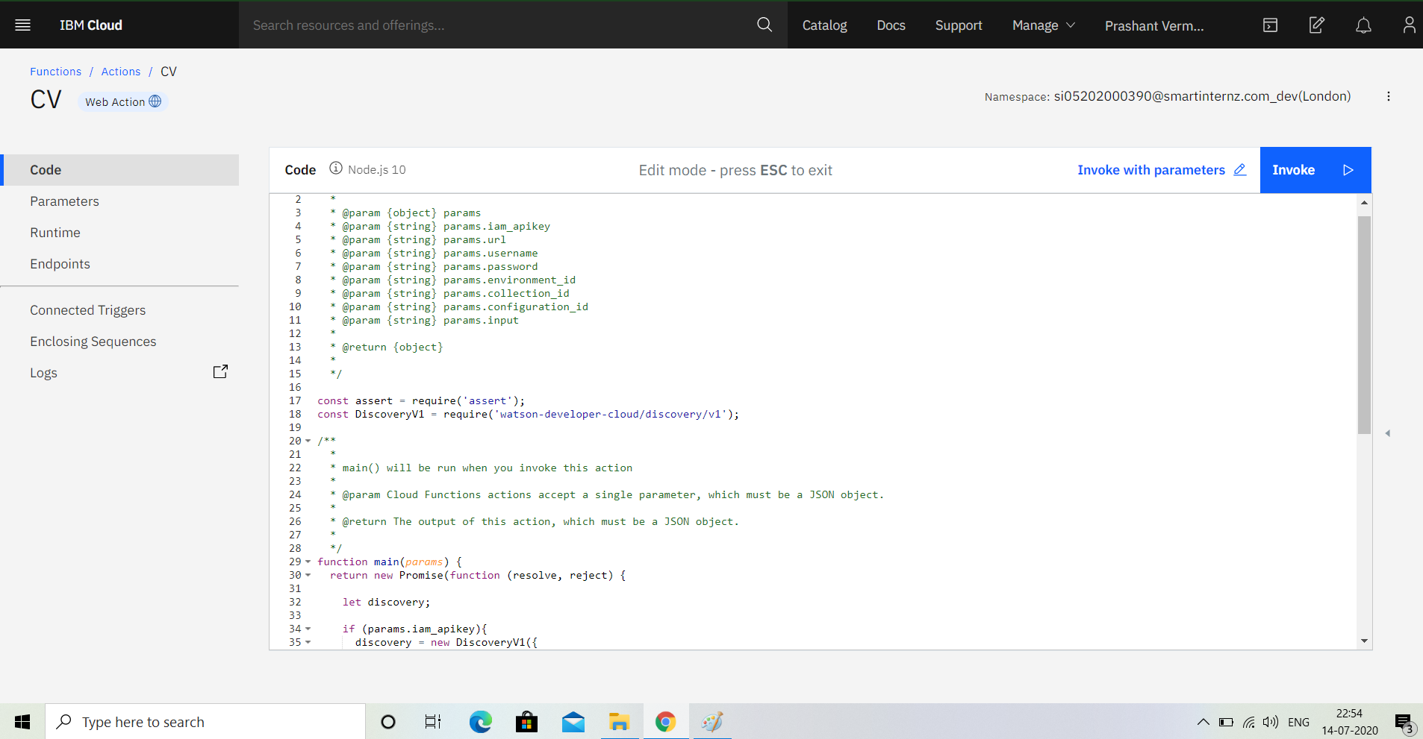

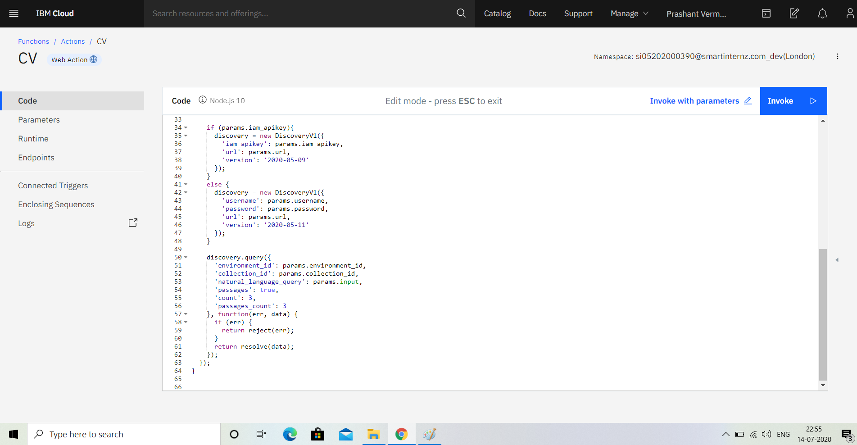

**Flowchart:**

This is the flow how we are going to do the tasks for the proposed problems.



1. The document is annotated using Watson Discovery

2. The user interacts with the backend server via the app UI. The frontend app UI is a chatbot that engages the user in a conversation.

3. Dialog between the user and backend server is coordinated using a Watson Assistant dialog skill.

4. If the user asks a product operation question, a search query is passed to a predefined IBM Cloud Functions action.

5. The Cloud Functions action will query the Watson Discovery service and return the results.



**6.Results**

The chatbot was successfully made using Watson assistant . All the services were

integrated using Node Red Application.



**7.Advantages and Disadvantages**

**Advantages:**

**1. Reduce human biasness**

Humans tend to be biased in some ways. Whether they realised it or not, some recruiters may make hiring decisions based on gender, ethnicity, age, looks and so on. An AI on the other hand, can be programmed to focus only on important factors such as candidates’ personality, skills, experience and qualifications.

**2. Saves time, money and increase in efficiency**

One of the main challenges for HR recruiters is to identify the best talent out of the many applications they receive each day. AIs can help to eliminate these manual tasks as they are programmed to obtain maximum efficiency in terms of time, costs and quality. Once the process of selecting candidates are fully automated, more data can then be gathered and efficiently assessed.

**3. Improve candidate experience and engagement**

HR recruiters are often inundated with tasks that take up most of their time, hence many face difficulties in maintaining good response time with their candidates, resulting in poor candidate experience and engagement. By introducing chatbots and virtual assistants, candidates will experience better interaction and response time, keeping them engaged and posted throughout the whole recruitment process.

**Disadvantages:**

**1. Issues with accuracy and reliability**

Although AI has come a long way, it is still far from being considered perfect. One of the major faults of applicant tracking system is that it lacks accuracy and reliability as it can easily be confused by formatting options. For example, an applicant might have all the good qualities that a recruiter seeks, but still fail to qualify into the AI’s list due to some unorthodox style of bullet points used in the application or resume.

**2. Too much dependency on certain keywords**

AI depends very much on certain keywords to scan through their pile of candidates. This can become a loophole for candidates who are familiar with how the system in AI is programmed, where they may include certain keywords that have the potential to trick the system and camouflage them as good fits for various positions, even though they are not.

**3. Lacks nuance of human judgement**

If a company is looking to diversify its workforce, using an AI in its hiring process may not be the best option. There are candidates out there who have atypical work experience but may still be the best fit for the position based on his or her personality, personal interests, character and work ethics. These are factors that require human judgement. Using an AI in this sense can greatly reduce the diversity in a workforce.

Automating the recruitment process in HR will save time, and consequently money as well as allowing recruiters to concentrate on other important tasks. Some of the disadvantages in implementing AI in HR recruitment are there for now, but eventually these problems will be solved just like any other challenges prior to them. More importantly, with the implementation of AI in every aspect of our lives, it is only a matter of time before it becomes mainstream even in HR recruitment.

**8.Applications**

Some applications can be: -

The ability to use augmented AI to automate repetitive, administrative tasks will be extremely valuable. There are 3 main ways this technology will change the role of the recruiter:

Recruiters will be able to conduct proactive strategic hiring rather than spend most of their time with reactive backfilling.

Recruiters will have more time to spend with candidates in-person to build relationships and help determine culture fit.

Recruiters will able to close the loop with hiring managers as AI allows them to use data to show recruiting KPIs including quality of hire.

1. **Conclusion**

This chatbot will be useful for the user to interview the Candidates and will test their Skills . Chatbots are quickly making transformational changes and allowing interviews to thrive through candidate interactions. The feedback and survey through chatbots strengthen the capabilities of candidates as they analyze the resumes of the Candidates using Knowledge Studio. Use of conversational AI chatbots only means better engagement and relentless need for AI through Recruitment in the near future.

Industry experts believe the future of AI for recruiting is Augmented Intelligence.

Augmented intelligence is the belief that you cannot fully replace human capabilities through technology. Instead, augmented intelligence suggests we should look to create technology to enhance human aptitude and efficiency.

1. **Future Scope**

AI for recruiting has several potential applications for automating high-volume, repetitive tasks such as resume screening and pre-qualifying candidates.

**1. Intelligent screening software**

Intelligent screening software automates resume screening by using AI (i.e., machine learning) on your existing resume database.

The software learns which candidates moved on to become successful and unsuccessful employees based on their performance, tenure, and turnover rates.

Specifically, it learns what existing employees’ experience, skills, and other qualities are and applies this knowledge to new applicants in order to automatically rank, grade, and shortlist the strongest candidates.

The software can also enrich candidates’ resumes by using public data sources about their prior employers as well as their public social media profiles.

Intelligent screening software that automates resume screening represents a massive opportunity for recruiters because it integrates with your existing ATS, which means it doesn’t disrupt your workflow, the candidate workflow, and requires minimal IT support.

**2. Recruiter chatbots**

Recruiter chatbots are currently being tested to provide real-time interaction to candidates by asking questions based on the job requirements and providing feedback, updates, and next-step suggestions.

AI-powered chatbots have a lot of potential to improve the candidate experience.

58% of job seekers say they have a negative impression of a company if didn’t hear back from the company after submitting an application, whereas 67% of job seekers have a positive impression of a company if they receive consistent updates throughout the application process.

**3. Digitized interviews**

Online interview software has been available for a while, but today’s technology claims to use AI to assess candidates’ word choices, speech patterns, and facial expressions to assess his or her fit for the role and possibly even the organization and its culture.